**ROAD ACCIDENT SQL REPORT**

**Current Year Casualties**

select SUM(number_of_casualties) as CY_Casualties

from road_accident

where YEAR(accident_date) = '2022'

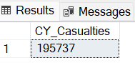

**Current Year Casualties for Dry conditions**

select SUM(number_of_casualties) as CY_Casualties

from road_accident

where YEAR(accident_date) = '2022' and road_surface_conditions= 'dry'

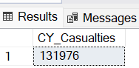

**Current Year Accidents**

select COUNT(Distinct accident_index) as CY_Accidents

from road_accident

where YEAR(accident_date) = '2022'

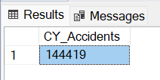

**Current Year Fatal Casualties**

select SUM(number_of_casualties) as CY_Fatal_Casualties

from road_accident

where YEAR(accident_date) = '2022' and accident_severity= 'fatal'

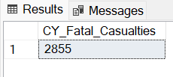

**Current Year Serious Casualties**

select SUM(number_of_casualties) as CY_Serious_Casualties

from road_accident

where YEAR(accident_date) = '2022' and accident_severity= 'serious'

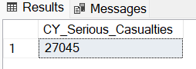

**Current Year Slight Casualties**

select SUM(number_of_casualties) as CY_Slight_Casualties

from road_accident

where YEAR(accident_date) = '2022' and accident_severity= 'slight'

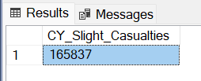

**Previous Year Casualties**

select SUM(number_of_casualties) as PY_Casualties

from road_accident

where YEAR(accident_date) = '2021'

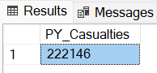

**Previous Year Accidents**

select COUNT(Distinct accident_index) as PY_Accidents

from road_accident

where YEAR(accident_date) = '2021'

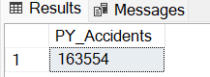

**Previous Year Fatal Casualties**

select SUM(number_of_casualties) as PY_Fatal_Casualties

from road_accident

where YEAR(accident_date) = '2021' and accident_severity= 'fatal'

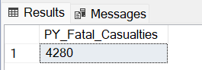

**Previous Year Serious Casualties**

select SUM(number_of_casualties) as PY_Serious_Casualties

from road_accident

where YEAR(accident_date) = '2021' and accident_severity= 'serious'

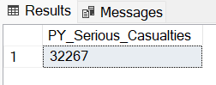

**Previous Year Slight Casualties**

select SUM(number_of_casualties) as PY_Slight_Casualties

from road_accident

where YEAR(accident_date) = '2021' and accident_severity= 'slight'

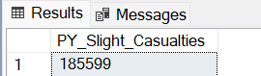

**The Number of CY Casualties by Accident Severity as a percentage**

select accident_severity,Cast( Cast (SUM(number_of_casualties) AS decimal(10,2))* 100/(select Cast (SUM(number_of_casualties) AS decimal(10,2)) From road_accident

where YEAR(accident_date)='2022' ) As decimal(10,2)) As percentage_of_casualties

From road_accident

where YEAR(accident_date)='2022'

group by accident_severity

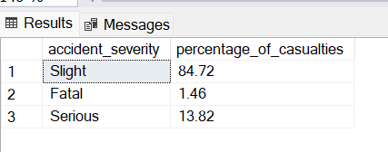

**YoY Growth on Casualties**

select Distinct Cast (((select Cast(SUM(number_of_casualties) AS decimal(10,2)) from road_accident

where YEAR(accident_date) = '2022') - (select Cast(SUM(number_of_casualties) AS decimal(10,2)) from road_accident

where YEAR(accident_date) = '2021')) * 100 / (select Cast(SUM(number_of_casualties) AS decimal(10,2)) from road_accident

where YEAR(accident_date) = '2021') AS decimal(10,2)) As YoY_Growth

from road_accident

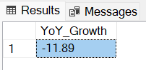

Similarly for fatal , slight Casualties YoY Growth can be calculated just using the WHERE clause.

**The Number of CY Casualties by Vehicle Type**

select

case

when vehicle_type In ('Agricultural vehicle') THEN 'Agricultural'

when vehicle_type In ('Car','Taxi/Private hire car') THEN 'Cars'

when vehicle_type In ('Motorcycle 125cc and under','Motorcycle 50cc and under','Motorcycle over 125cc and up to 500cc','Motorcycle over 500cc','Pedal cycle') THEN 'Bike'

when vehicle_type In ('Bus or coach (17 or more pass seats)','Minibus (8 - 16 passenger seats)') THEN 'Bus'

when vehicle_type In ('Goods 7.5 tonnes mgw and over','Goods over 3.5t. and under 7.5t','Van / Goods 3.5 tonnes mgw or under') THEN 'Van'

else 'Other'

end AS Vehicle_Type , SUM(number_of_casualties) as CY_Casualties

from road_accident

where YEAR(accident_date) = '2022'

group by

case

when vehicle_type In ('Agricultural vehicle') THEN 'Agricultural'

when vehicle_type In ('Car','Taxi/Private hire car') THEN 'Cars'

when vehicle_type In ('Motorcycle 125cc and under','Motorcycle 50cc and under','Motorcycle over 125cc and up to 500cc','Motorcycle over 500cc','Pedal cycle') THEN 'Bike'

when vehicle_type In ('Bus or coach (17 or more pass seats)','Minibus (8 - 16 passenger seats)') THEN 'Bus'

when vehicle_type In ('Goods 7.5 tonnes mgw and over','Goods over 3.5t. and under 7.5t','Van / Goods 3.5 tonnes mgw or under') THEN 'Van'

else 'Other'

END

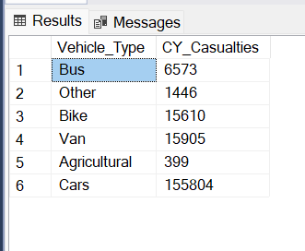

**The Number of CY and PY Casualties by month**

SELECT

DATENAME(Month, accident_date) AS Month_Name,

SUM(CASE WHEN YEAR(accident_date) = 2022 THEN number_of_casualties ELSE 0 END) AS CY_Casualties,

SUM(CASE WHEN YEAR(accident_date) = 2021 THEN number_of_casualties ELSE 0 END) AS PY_Casualties

FROM

road_accident

GROUP BY

DATENAME(Month, accident_date), MONTH(accident_date)

ORDER BY

MONTH(accident_date);

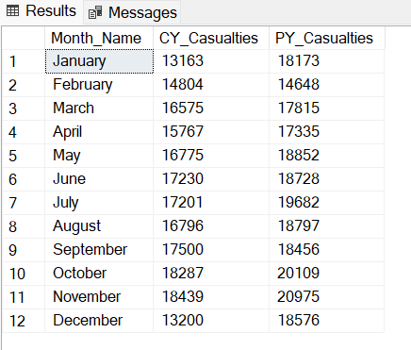

**The Number of CY Casualties by Road Type**

select road_type,SUM(number_of_casualties) as CY_Casualties From road_accident

where YEAR(accident_date)='2022'

group by road_type

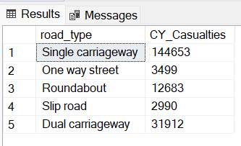

/*Find the number of casualities by Urban/Rural area */

select urban_or_rural_area,Cast( Cast (SUM(number_of_casualties) AS decimal(10,2))* 100/(select Cast (SUM(number_of_casualties) AS decimal(10,2)) From road_accident

where YEAR(accident_date)='2022' ) As decimal(10,2)) As percentage_of_casualties

From road_accident

where YEAR(accident_date)='2022'

group by urban_or_rural_area

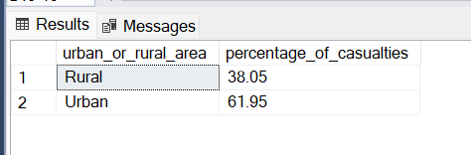

**The Number of Casualties by Location**

select Top 10 local_authority,SUM(number_of_casualties) As Total_Casualties

From road_accident

group by local_authority

order by Total_Casualties DESC

